Hackensack Middle School
6th Grade Social Studies
Mr. Davina (Room 313)
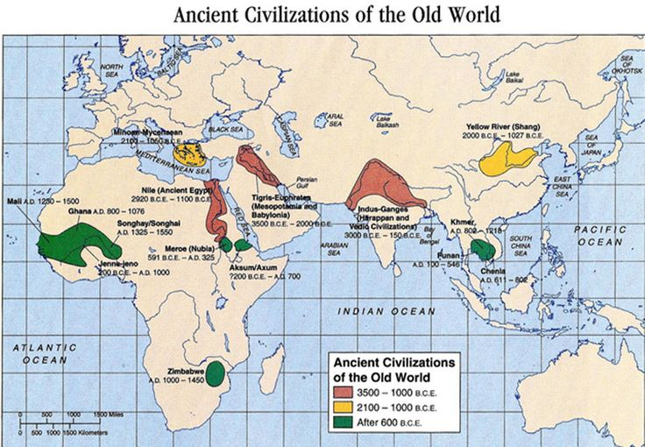
- Course Information:

Your 6th grade Social Studies class will focus on Ancient Civilizations. The ancient civilizations we will study are Mesopotamia, Egypt, India, China, Greece, and Rome. In Unit 1, we will be studying archeology, geography, and hominids, including their evolution into early humans and the agricultural revolution that led to the first civilizations. Additionally, there will be a unit on the four major world religions. The goal of the course is to understand that each of these early civilizations developed around similar environmental settings while maintaining a unique identity to separate it from the others.
In addition to the content you will learn, I will also introduce new skills to better prepare pupils for their futures as students and members in our modern society. There will be an emphasis placed on locating, analyzing, and evaluating primary and secondary texts as it is a key aspect of doing social studies. This year, there will also be an emphasis placed on writing skills. By the end of the year students will better understand how to write a proper essay in MLA format. Students will also practice their organization skills, time-planning, note-taking, good internet practices, and proper ways to communicate.

- Contact Information:
Email Address: j.davina@hackensackschools.org (Preferred)
Emails: I will attempt to reply to emails as early as possible. I usually check my emails early in the morning (7:30-8am), lunch time, and after school (3-3:30pm).

School Phone Number: (201) 646-7842 (ask to leave voicemail for Mr. Davina or to leave a message in my mailbox)

Website: http://www.hackensackschools.org/webpages/jdavina/
You may also navigate to this site through the school Website > Teachers and Parents > Teacher Websites

Google Classroom: Details to Follow

- Grading Breakdown:
- Tests/Writing Assignments - 40%
  - Tests will be announced as early as possible.
      - Study guides will be provided approximately a week before the test either in class or via Quizlet.
      - All tests are closed notes.
  - Writing Assignments - Writing Assignments will be assigned periodically throughout each marking period and will be counted as a test grade. These are often done at home, outside of class and vary in length depending on the assignment.

- Quizzes - 30%
  - Pop Quizzes - Pop Quizzes will be conducted periodically throughout each unit with questions related to the topic(s) recently covered in class.
    - These will not be announced however they will be open note so it is important to always keep your notes in a safe place.
  - Quizzes/Tests - Larger quizzes and exams will be given accordingly throughout each unit and are always announced.
    - All announced quizzes are closed notes.
    - There are no make-ups for quizzes and tests unless you are absent from school. It is the students responsibility to see me as soon as possible upon returning to school to schedule a make-up date.

- Class Participation/Behavior - 10%
  - Each marking period class participation will be graded out of a score of 100 points. Each week, the teacher will change that score based on effort and behavior in and out of the classroom.

- Classwork - 10%
  - Certain class assignments will be graded. These may include Do Nows, exit activities, or reading or writing assignments, etc.
- Homework - 10%
  - Homework will be assigned accordingly based on the lessons.
  - Late homework/projects will receive a maximum of 3/4 credit for up to two classes late; anything beyond two days will receive a maximum of half credit
    - Students have until the end of the unit the assignment was a part of to turn it in. NO late assignments will be accepted after the end of a unit.

Projects/Essays - Throughout each unit, different projects or essays may be assigned. Students are given at least 3 days to complete any projects or essays. They will be counted as quizzes or tests depending on the assignment.

Extra Credit: Extra credit will be provided on a student to student basis. Extra credit is available for students whose marking period grade is border line and want to possibly bring it up.
- Extra credit is not always offered so students should not rely on extra credit assignments!
- Classroom Materials

- Textbook: Spielvogel, Jackson J. Discovering Our Past: A History of the World. Bothell, Wash.: McGraw-Hill Eduaction, 2013. Print.
This book is only in class. Students will be provided with login access for the online version to use outside of class. In special cases only, students will be provided the opportunity to take the book out of class if necessary.

- Supply List:
  - 1" - 1.5" 3-Ring Binder
  - Dividers w/ tabs for inside the Binder
  - Loose leaf paper in binder
  - 2 pocket Folder
  - Pens/Pencils (no red ink please)
  - Highlighters
  - Daily Planner (Provided by the school)
V. Procedures/Routines/Expectations in the Classroom
- All district and school rules apply in this classroom (no gum, candy, coats, hats, electronic
devices, plagiarism, dress code, etc.)
- BE ON TIME – in class before the late bell rings working on the Do Now activity.
- BE PREPARED – necessary class materials, in your seat, working on the Do Now activity
- BE RESPECTFUL - paying attention, listening to the teacher or other students, working on your assignment, not working on other class work, proper use of classroom materials/objects, etc.
- Upon entering the classroom, students should be in their seat, reading the objective for the day and working on their Do Now assignment.
- Any handouts, notes, or work that is completed in class should be automatically reviewed as your homework for the night in addition to any other assignment that might be given.
- Any bathroom or water requests should wait until the Do Now is completed and before the last ten minutes of class
- Students are responsible to get information from any missed classes from the teacher either before school, after class, or after school.
- To discuss anything private, make up work, and or review grades please see me outside of regular class time as well, unless otherwise told by the teacher.

GRADE 6 SOCIAL STUDIES – MR. J. DAVINA (2016-2017)
STUDENT/PARENTAL ACKNOWLEDGEMENT FORM
By signing below, I acknowledge that I have read and understand the above information and the guidelines for this class.

______________________________________ ____________________________________ ___________ Student's Name (Please Print) Student’s Signature Date

______________________________________ ____________________________________ ___________
Parent/Guardian’s Name (Please Print) Parent/Guardian’s Signature Date

In an effort to get to know your child better, if there is anything you feel is important for me to know about them as their teacher (visual/hearing problems, no internet at home, scheduling issues, etc.), please feel free to use the lines below. Thank you!
___________________________________________________________________________________________
___________________________________________________________________________________________

___________________________________________________________________________________________

___________________________________________________________________________________________

___________________________________________________________________________________________

___________________________________________________________________________________________

___________________________________________________________________________________________

___________________________________________________________________________________________

___________________________________________________________________________________________

