Daily Prophet
October 25, 2010
Price: 5 Knuts
The
Faithfully Serving the Wizarding Community
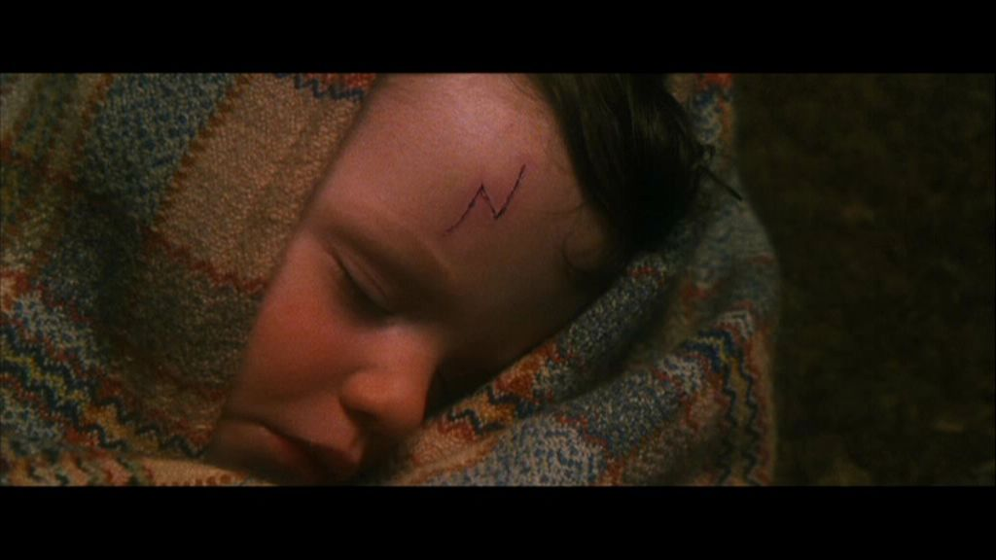
This Week inHistory – October 31
“The Boy Who Lived”
It seems like just yesterday
that we raised our glasses and toasted
Harry Potter, The Boy Who Lived, after
he got rid of . . . You Know Who. Now
Bundle of Blankets. Inside, just visible was a baby boy, fast asleep. Under a tuft of jet-black hair over his forehead they could see a curiously shaped cut, like a bolt of lightning. J.K. Rowling
Harry is in his first Year at Hogwarts School of
Witchcraft and Wizardry. Where did time Go?
The Daily Prophet has interviewed some of the most influential witches and wizards of our time to find out their memories of that infamous day. Professor Minerva McGonagall, Deputy Headmistress of Hogwarts School and head of Gryffindor House, recalls when Harry was dropped off at his only surviving relatives’ house. She predicted Harry would be a legend in his own time. She remembers telling Professor Dumbledore, “He’ll be famous – a legend – I wouldn’t be surprised if today was known as Harry Potter day in the future – there will be books written about Harry – every child in our world will know his name!” [Source: J,K. Rowling p 13]

Rubeus Hagrid, Keeper of Keys and Grounds at Hogwarts School, teared up remembering that night. “I held Lit’l ‘Arry in me arms in a bundle-o-blankets. Mighta cried some. Got to drive a flying motorcycle, I did. Borrowed it from Sirius Black. I probably shouldn’t have told you that. I am so proud of Har-ryyy.” Hagrid could not continue the interview because he was sobbing, blowing his nose into a handkerchief as large as a parachute.

Now that Harry has rejoined the wizarding community, he will experience his first “Harry Potter Day” surrounding by friends at Hogwarts. It should be a magical day for all! “To Harry Potter – the boy who lived!” [Source: J,K. Rowling p 17]

