Graphs

SECTION A Family Letter: Graphs
Dear Family,
Vocabulary
These are the math words we are learning:
coordinate plane plane formed by horizontal and vertical number lines intersecting at zero on each
ordered pair a pair of numbers that names a location on a coordinate plane
origin the point where the axes intersect on a coordinate plane; has the coordinates (0, 0)
quadrant one-quarter of the coordinate plane, bounded on two sides by the axes
x-axis horizontal number line on the coordinate plane
y-axis vertical number line on the coordinate plane

The student will be introduced to the coordinate plane, which is an extension of the number line. A coordinate plane is labeled below.

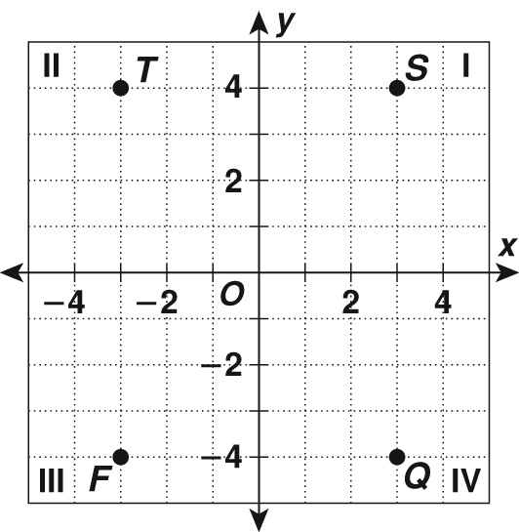

The coordinate plane is divided into four quadrants by the
x- and y-axes. The origin is the point where the axes intersect and is identified by the ordered pair (0, 0). An ordered pair (x, y) gives the x- and y-coordinates of a point.
The x-coordinate tells how many units to move left or right from the origin. The x-coordinate is negative left of the origin. The y-coordinate tells how many units to move up or down from the origin. The y-coordinate is negative below the origin. The student will use ordered pairs to plot points in all four quadrants.
Give the coordinates of Point T on the coordinate grid above. Start at the origin. Point T is 3 units left and 4 units up. The coordinates of T are (–3, 4).

Graphs

SECTION A Family Letter: Graphs continued
The student will learn about graphs that show relationships between speed and time, time and distance, or speed and distance. These graphs may be presented on a coordinate grid or may be presented on a set of axes without units labeled.
Shown below are samples of graphs

An interpretation of Graph A might be: Larry ran at the same pace to the mailbox and back.
An Interpretation of Graph B might be: Danielle walked to the store. She shopped for a while and then walked back home at a slightly faster pace than she walked to the store.
An interpretation of Graph C might be: From the library, Greg started walking home, but ran into a friend and stopped to talk for a while. When he started walking again, he had to walk faster so that he would not be late for dinner.
These interpretations are just one possible scenario for each graph. In the chapter, the student will interpret graphs such as these.
You can discuss with the students how a steeper line can mean a faster pace and why a horizontal line means a person is standing in the same place as the time continues to increase.
You can practice interpreting graphs by drawing other graphs and asking the student to give you a situation that matches the graph you made.
Sincerely,
Graphs

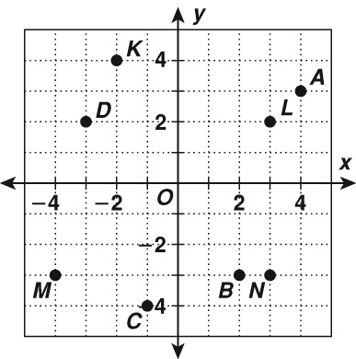
SECTION A At-Home Practice: Graphs
Identify the quadrant that contains each point.
1. K 2. L 3. M 4. N
_______ _______ _______ _______
Give the coordinates of each point.
5. A 6. B 7. C 8. D
_______ _______ _______ _______
To practice the skill of interpreting graphs, physically act out each description below and have the student sketch a graph to match your action.
9. Slowly walk down a hallway away from the student. Continue walking, but speed up until you reach the end of the hallway. Stop and stay there.
10. From the end of the hallway where you stopped for Question 9, take three steps toward the student. Stop and stand for 15 seconds. Start walking again and take 3 steps. Stop and Stand for 15 seconds. Start walking again and take 6 steps. Stop and stand for 15 seconds. Then walk at a steady pace to the location of the student.
11. Walk down a hallway away from the student at a steady pace. When you get to the end of the hallway, turn around and walk back at the same pace you were walking down the hallway.
12. Walk at a fast pace away from the student about half way down the hallway then turn and rush back to the student.

Answers: 1. Quadrant II 2. Quadrant I 3. Quadrant III 4. Quadrant IV. 5. (4, 3) 6. (2, −3) 7. (−1, −4) 8. (−3, 2)
Graphs will vary, but should generally match each description.
9. From the origin, the line segment slants upward and then a connecting line segment shows a steeper slant for the second half of the time.
10. From the top of the y-axis, a short line segment slants downward, then a short horizontal line segment, followed by another short line segment (the same length as before) slanting downward and another short horizontal line segment (the same length as before), followed by a downward line segment that is twice as long as the previous ones and another horizontal line segment the same length as the two previous. The last line segment slants downward to the x-axis.
11. Two line segments that form an upside down V; the segments start at the origin and end on the x-axis away from the origin.
12. From the origin, a line segment slants upward to about halfway up the y-axis and then another segment from that point slants downward at a steeper slope to the x-axis.
Graphs

Family Fun: Plotting Points
Directions
Solve each problem. Match the answer to an ordered pair and plot the point. Connect the ten points with straight lines to find the mystery shape. (Hint: If you plot all of the ordered pairs, you will not get the correct answer.)
−40 • 6 = ____________ −18 + (−4) = ____________ 8 • (−8) = ____________ (−8)² = ____________
72 ÷ (−9) = _____________ 35 − (−6) = _____________ −3 • −4 • 2 = _____________
300 ÷ (−10) = _____________ −12 + (−38) = _____________
−48 ÷ −6 = _____________
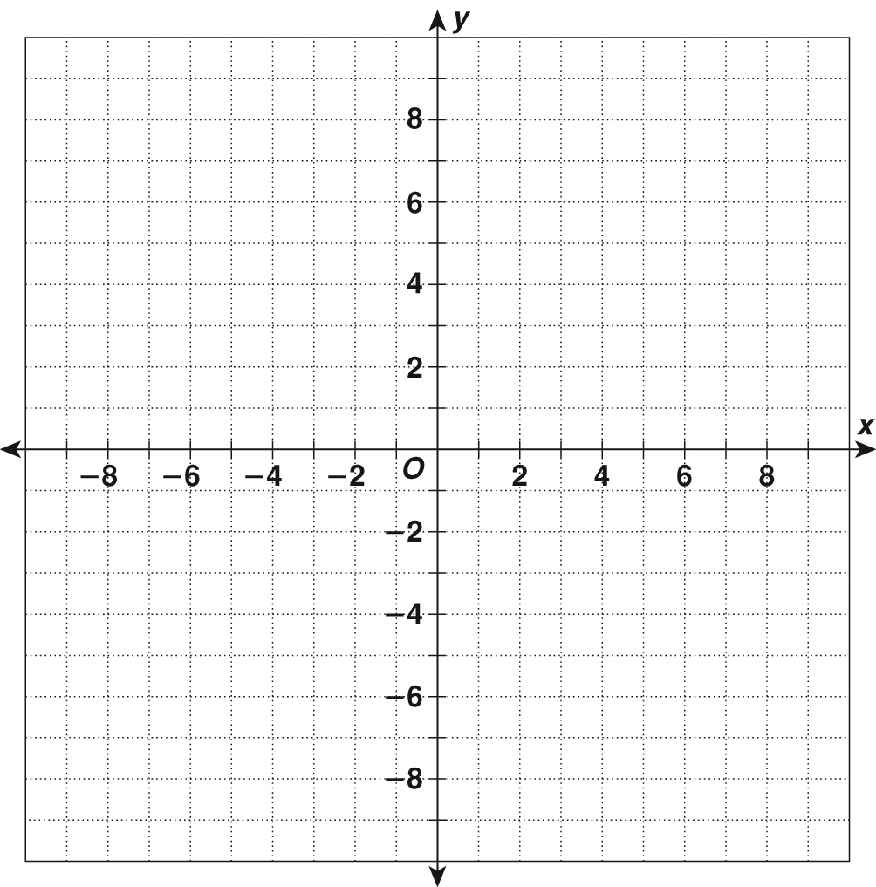

Ordered Pairs | Answer
(−8, 5) | −41
(0, 0) | −240
(2, 5) | 25
(−3, 0) | 24
(−6, 3) | −22
(−3, −3) | 64
(3, 0) | 41
(3, −3) | −30
(6, 3) | −50
(3, 3) | −8
(−3, 3) | −64
(−2, 1) | −24
(0, 6) | 8

Answers: −240, −22, −64, 64, −8, 41, 24, −30, −50, 8, The mystery shape is a star.

Graphs

SECTION B Family Letter: Graphs of Linear Equations
Vocabulary
These are the math words we are learning:
constant of variation the fixed number k in a direct variation equation
direct variation a linear relationship between two variables that can be written in the form
y = kx or k =
rate of change the ratio of two quantities that change, such as slope
slope the measure of the steepness of a line; the ratio of rise to run
Dear Family,
The student is learning about linear equations and linear functions. A linear equation is an equation whose graph is a line. The solutions of a linear equation are the points that make up its graph. A linear function is a function whose graph is a nonvertical line.
The Graph of a linear function y = −2x + 3 is shown below.
A table of points on the line is included.
x | y | (x, y)
−2 | 7 | (−2, 7)
0 | 3 | (0, 3)
2 | −1 | (2, −1)

Place each ordered pair on the coordinate plane. Then connect the points to form a line.

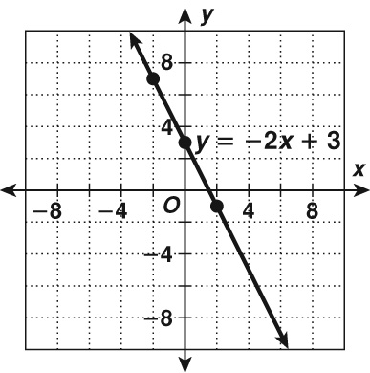

The slope of a line is a measure of its steepness. Slope is defined as the ratio of rise to run: slope = . The rise of a line is a vertical change, or the change in the y-coordinate. The run of a line is a horizontal change, or the change in the x-coordinate. If a line rises from left to right, its slope is positive. If a line falls from left to right, its slope is negative.
Graphs

SECTION B Family Letter: Graphs of Linear Equations continued

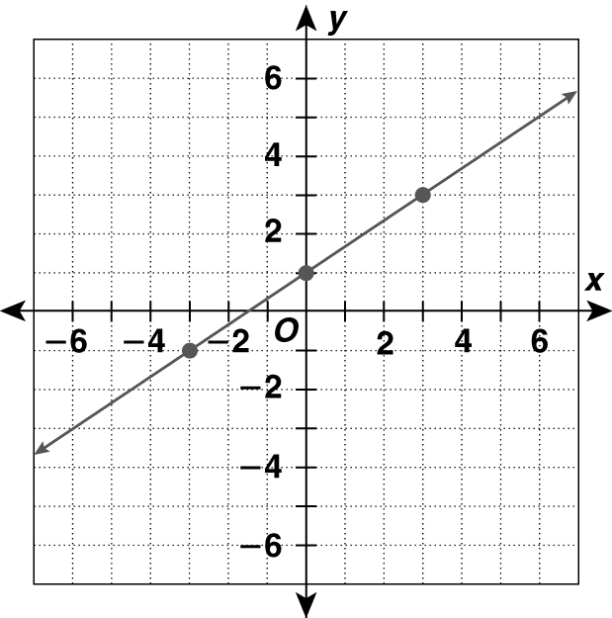
Tell whether the slope is positive or negative. Then find the slope.

The line rises from left to right, so the slope is positive.
slope =
= The rise is 2; the run is 3.
In the graph above you can find the x- and y-intercepts, and use them to find the slope.
The line intersects the x-axis at (−1, 0).
The x-intercept is −1.
The line intersects the y-axis at (0, 1).
The y-intercept is 1.

The rise from the x-intercept to the y-intercept is 1.
The run from the x-intercept to the y-intercept is 1,
So, .
As you can see, the slope of a line is constant regardless of the points used to count the rise and run.
Sincerely,

Graphs

SECTION B At-Home Practice: Graphs of Linear Equations

Tell whether the slope is positive or negative.

1.
______________
2.
______________

Use the given slope and point to graph the line.

3. slope = point = (2, 4)
4. slope = −3, point = (1, 1)

Tell whether each graph shows a constant or variable rate of change.

5.
______________
6.
______________

Answers: 1. negative 2. positive 3. 4. 5. variable 6. constant

Graphs

Family Fun: Magic Pictures
Directions
• Create your own magic by plotting the points to see what shape is revealed.
Then find the slope between each set of points.
Ordered pairs | Slope
(x, y)
H(6, 12) | AB ________
G(2, 10) | BC ________
F(0, 6) | CD ________
E(2, 2) | DE ________
D(6, 0) | EF ________
C(10, 2) | FG ________
B(12, 6) | GH ________
A(10, 10) | HA ________


What patterns can you identify in the slope?_______________
The slopes are: AB = −2, BC = 2, CD = , DE = −, EF = −2, FG = 2.
Sample pattern: Opposite sides of the Octagon have slopes that are equal.
Answer: The mystery shape is an octagon.

