Absolute location:
The location on the Earth's surface that can be shown by latitude and longitude.
Equator:
An imaginary circle around the middle of the Earth.
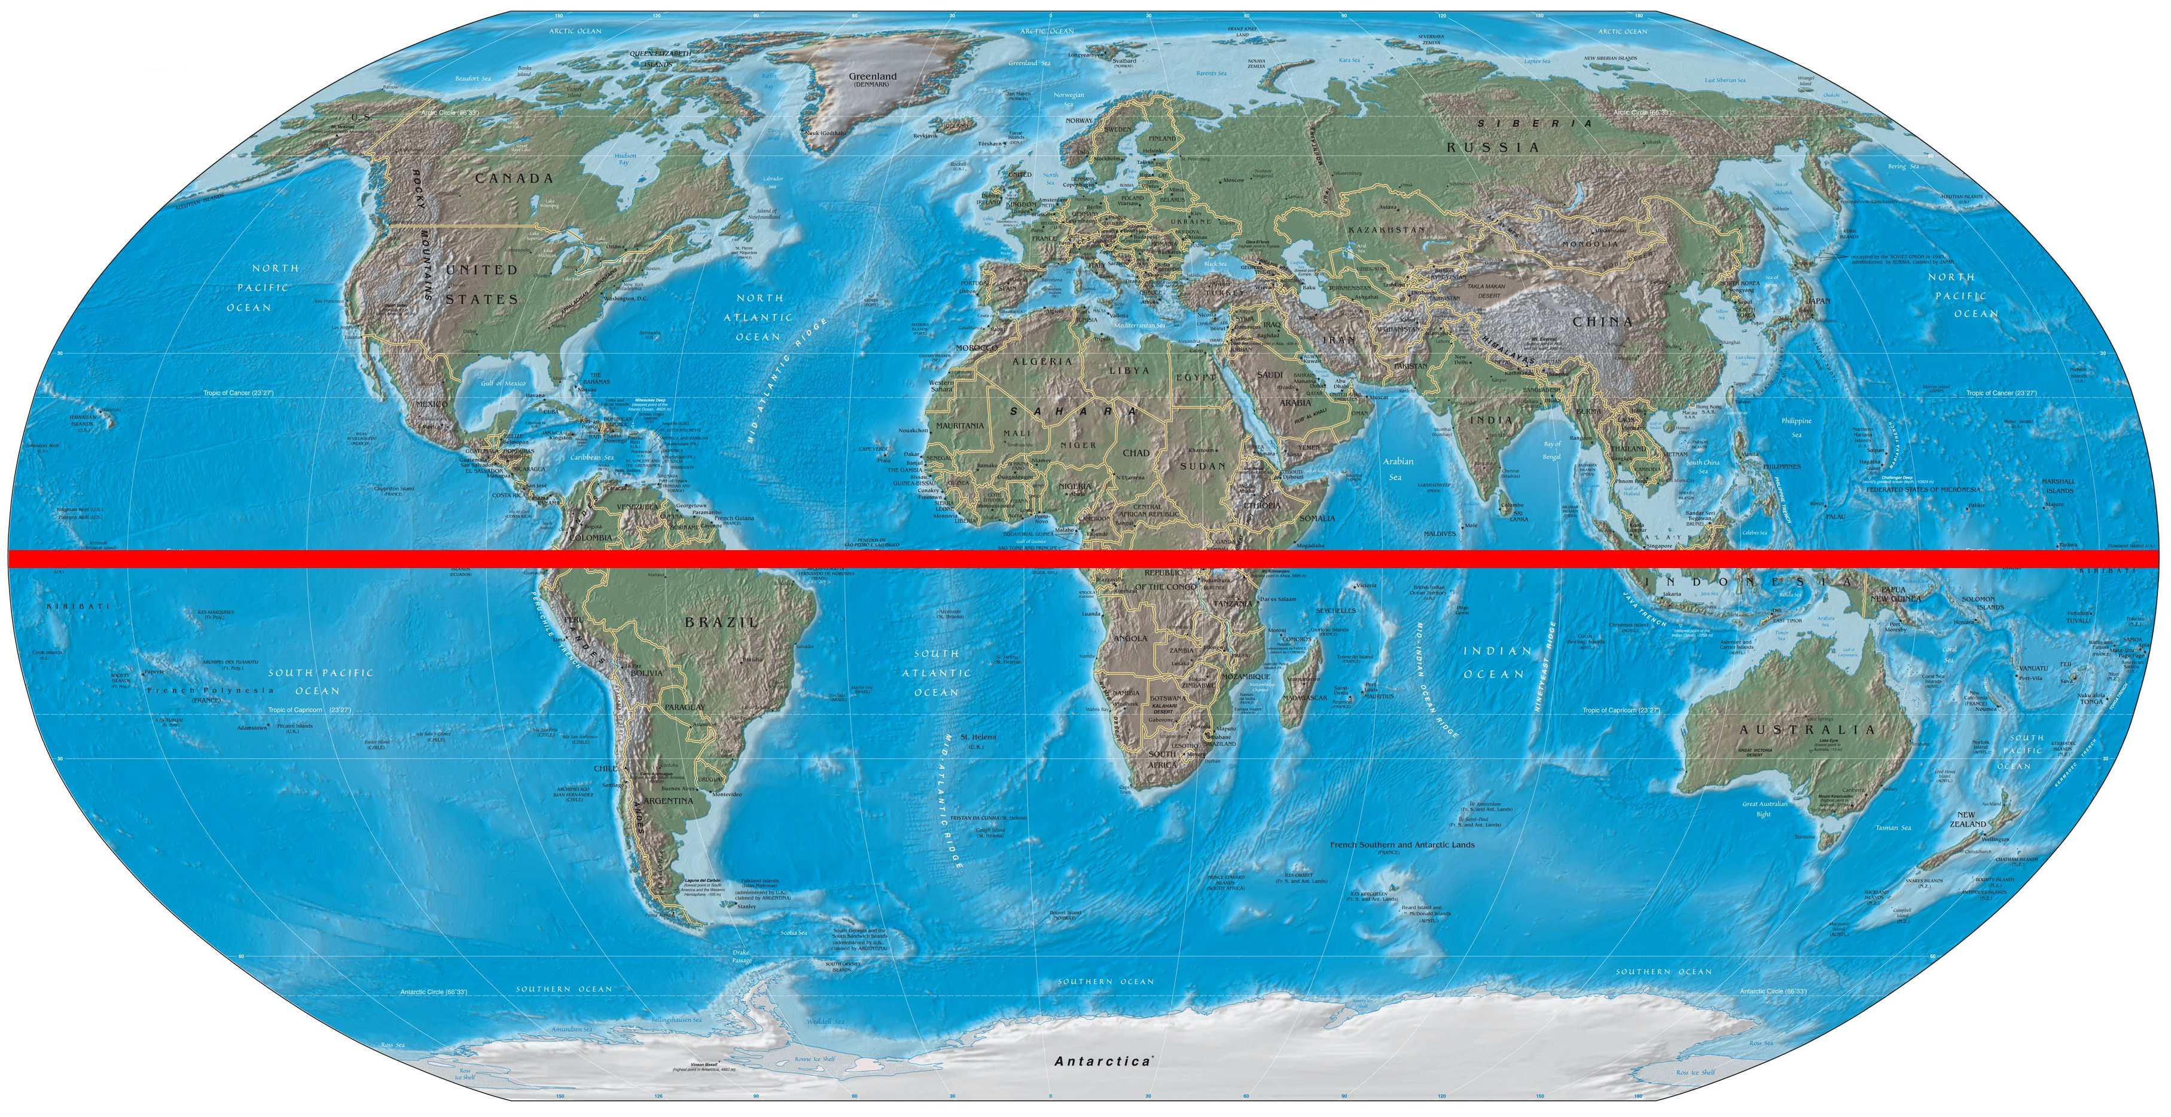
Hemisphere:
Half of the Earth
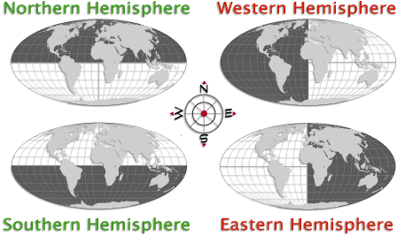

Longitude:
Imaginary lines on the Earth, running from north to south, ( Up and Down)
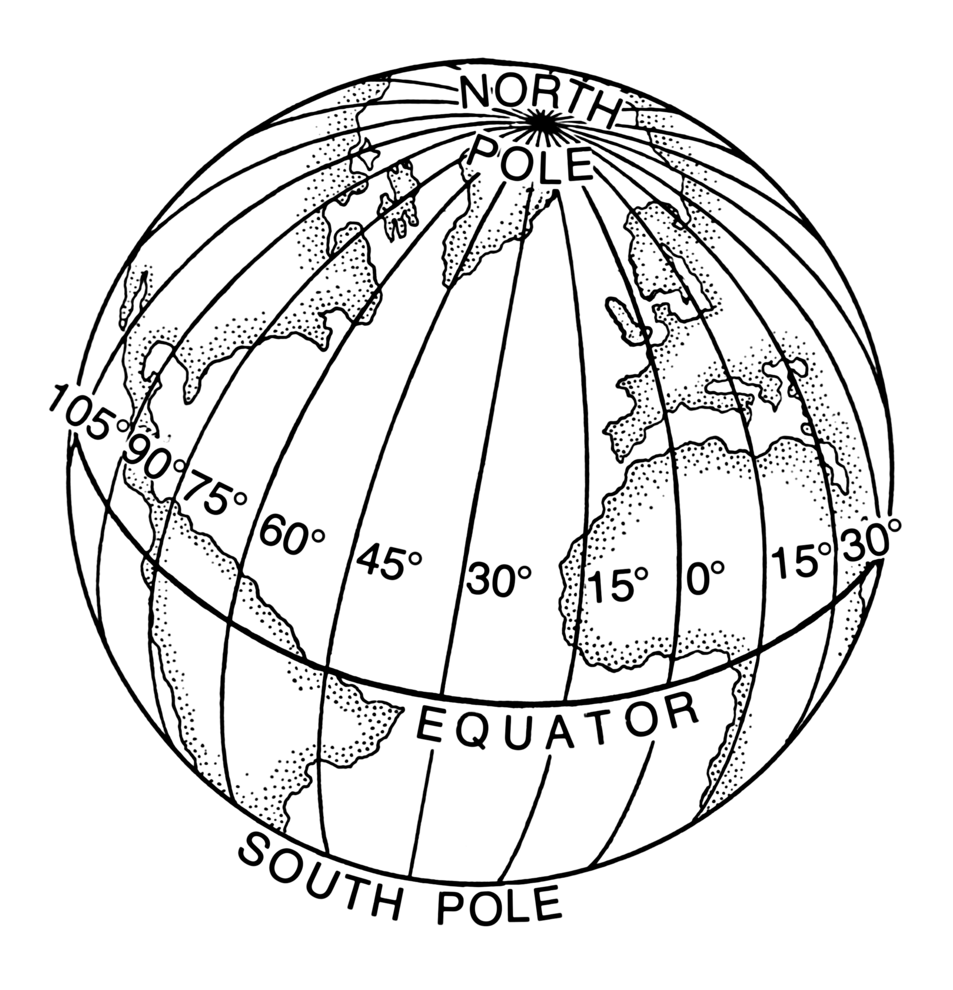
Latitude:
Imaginary lines on the Earth that run parallel to the Equator (Left to Right)
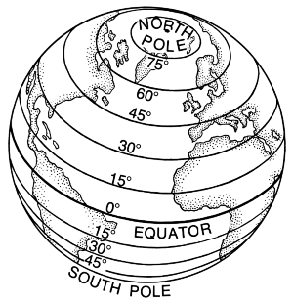

Legend:
A key to what the symbols or pictures in a map mean.
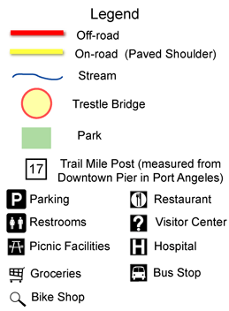
Prime Meridian:
An imaginary line running from north to south (0 degrees Longitude)
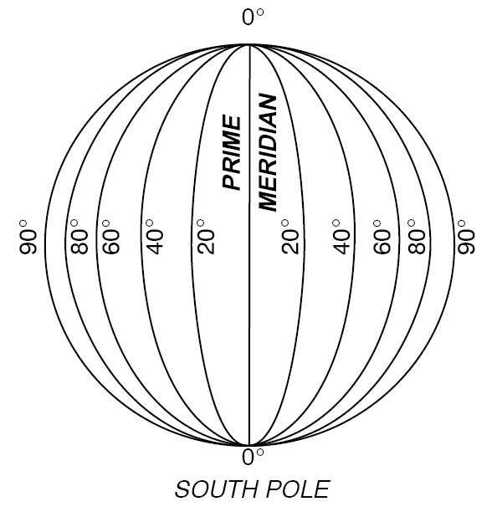

Scale:
The relationship between a measurement on a map and the distance it represents on the Earth's surface.
