During the Middle Ages, there were neither restaurants nor hotels open to the public so people often were offered food and shelter from nuns and monks. Hostels were available for travelers to stop for the night. In addition, convents and monasteries offered the only facilities to treat the sick and injured.
During the Middle Ages books were copied by hand because the printing press had not been invented.
The Crusades
The Crusades were a series of wars fought by European Christians to take back the Holy Land from the Muslims. The Muslims believed that the Holy Land was theirs and the Christians had no right to it.
Melons, apricots, lemons, oranges, sugar, and rice were among the new foods the Crusaders came across in the East.
Crusaders started to use spices such as pepper, cloves, cinnamon, and nutmeg in their food.
The Crusaders' ships returned filled with foods and spices. In addition, they brought back Persian rugs, Chinese silks, and Damascus steel. After that, the European demand for these products increased greatly.
____________________________________________________________
The Plague spread from Europe to Africa and Asia.
In 1348 it hit Egypt and killed thousands in Cairo alone.
In 1349 the Plague struck east of the Mediterranean Sea, all the way to the Persian Gulf resulting in thousands of people in Baghdad dying.
People called the Plague the most terrible of terrors because no one knew what caused the disease. One third of the population of Western Europe was wiped out.
The children's rhyme "Ring Around the Rosie" came from the plague years.
The "ring" is the rash around the eyes that develops with the illness.
The "posies" were flowers people carried in the hope of warding off the plague.
The "all fall down" refers to people dying from the Plague.
Today the bubonic plague can be cured with antibiotics. There are vaccines against the bubonic plague but they don't always work.
_____________________________________________________________
Suger created the Gothic style for buildings.
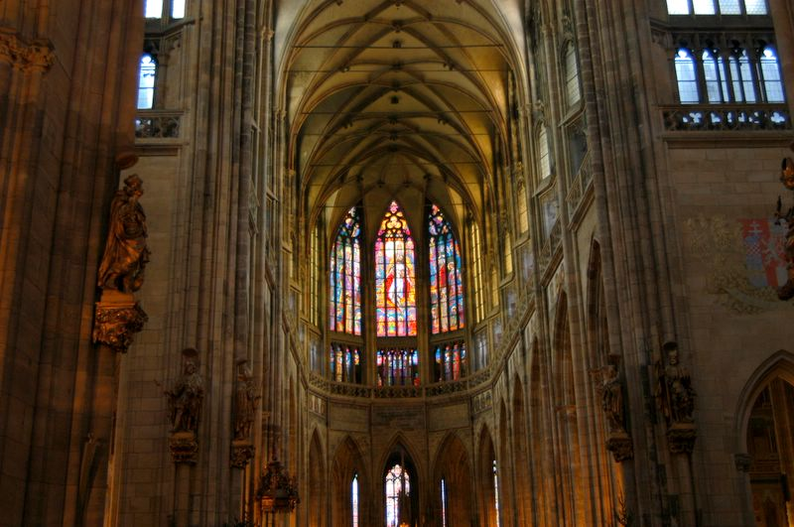
14th Century->Prague
Saint Vitus Cathedral
Muslims established a Muslim state in what is today Spain.
Charlemagne respected learning and set up a school at his court and put an educated man from England, named Alcuin, in charge of it.
The crown of Charlemagne.
Alcuin>>
After Charlemagne's son died, the Frankish kingdom was divided into 3 parts and that threw Europe into a chaotic state once more.
Europeans were so afraid of the Vikings because the Vikings destroyed villages, churches, and ships at sea.
Two other terms are used to describe the period known as the Middle Ages:
1. medieval (Latin for "Middle Age")
2. Dark Ages-this term was used because it was thought that the light of civilization went out in Europe during this time. However, this term is wrong and is not used anymore.
Vikings worshipped many gods and believed that a god named Odin was the supreme king god.
<<ODIN< SPAN>
Thor was the Viking god of the sky who was responsible for good harvests, wind, rain, thunder, and lightning,
According to Viking beliefs, heroes who died in battle were taken to Valhalla, the great hall of Odin, for more battles and feasts.
The Normans
The date 1066 is so important to English history because it is the date when William, Duke of Normandy, later known as William the Conqueror, defeated Harold, the Saxon king of England, which resulted in a Norman, French-speaking king being installed on the throne of England.
The Norman conquest changed England as the new kingdom blended Norman and Saxon culture and language.
___________________________________________________________________
Feudal kings divided their lands into fiefs to control their lands and reward nobles for their loyalty and support.
The Difference between a Vassal and a Serf:
Vassals were nobles who received a fief, or land grant, from the king; serfs were peasants who worked the land.
A serf might want to live in a town to experience freedom and live a life less harsh than on the manors.
Stages in Becoming a Knight:
Stage 1- This stage began at age 7. Pages were expected to attend to knights and know etiquette.
Stage 2- A page became a squire at a church ceremony, during which a priest blessed him. The squire received a belt and a sword.
Stage 3- Before the ceremony that would make him a knight, a squire prayed and fasted all night. The next day a noble dubbed him a knight by tapping him three times with a sword.
The Code of Knighthood:
*Chivalry-knights were supposed to follow this code of conduct.
*Be a good Christian.
*Defend the Church.
*Know poetry and music.
*Have good manners.
The Tough Part of being a Knight:
*Knights had to have atleast 3 horses.
*Knights had to have a suit of armor.
*Knights had to have squires to serve them.
(All of the above were expensive to maintain and acquire.)
**Some knights tried to make a living by fighting in tournaments such as jousting.
_________________________________________________
England's King John was forced by his vassals to sign the Magna Carta.
During the Middle Ages, European life was hard! Agriculture was poor, disease and war were common, and most people did not live past 40.
After A.D. 1000 life improved. Trade revived, travel increased, towns expanded, and more food was produced.

