Name: _________________________________ Date: ________________
Life Science Period: ______________
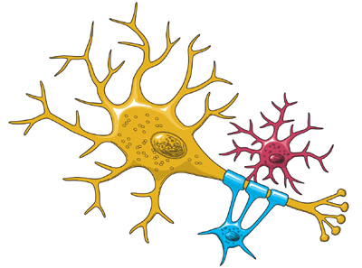
Unit One – The Scientific Method

Lab: A Message Traveling Along Nerves
Observation
It is surprising how quick we are when it comes to jumping out of the way of something coming toward us. Or how fast we are when we need to put on the breaks of a bicycle that we are riding. We seem to be very quick when it comes to grabbing a ball as it goes by us. The time it takes for a message to enter your eyes and reach the tip of your fingers must be very fast. Let us try to figure out a way to find the amount of time it takes information to move along our nerves.

Problem
Does hand dominance affect the rate at which information travels from your eye through the brain, and then to your hand?

Hypothesis

Materials

- Ruler
- Pencil
- Lab paper
- Graph paper
- Partner
- Calculator
Procedure

- A partner will hold a ruler at one end so it hangs vertically, and the "bottom" end is dangling between your right hand’s index finger and thumb. Your finger and thumb should be at zero centimeters, and about a half an inch or one centimeter away from the ruler on each side. This space on each side will be enough for the ruler to fall in.

- When your partner thinks you are ready, he or she will drop the ruler without warning. As the ruler falls, it is up to you to stop it as quickly as you can by pinching your finger and thumb together.

- Record in the chart below the distance at the point at which you stopped the ruler.

- Repeat this process at least three times, recording the results each time.

- Repeat steps 1-4 with your left hand.

- Switch roles with your partner so that he/she can obtain their data.

- Using Table 2, convert the data that you recorded in centimeters to time in seconds.
Data

Table 1 - Results

Trial # | Right Hand |  | Left Hand
Trial # | Distance Ruler Fell Centimeters | Time  Seconds | Distance Ruler Fell  Centimeters | Time  Seconds
1
2
3
Total
Average

To get an average: After adding up the three numbers, divide the total by three to get
the average distance.

Table 2 - Time it takes an object to fall a specific distance.

Analysis

A. Graph - On a separate sheet of graph paper, construct a double line graph expressing
the results from your right hand and your left hand in all 3 trials of this lab.

X axis: Trial numbers
Y axis: Response time in seconds

B. Use Table 2 to convert your dominant hand’s average distance into a unit of time.

- The time for a "message" to travel from your eye through the brain to your dominant hand is equal to ________ seconds.
(This is the answer to the question that we asked in the problem!)

- Because the distance from your eye to the tip of your hand is about one meter you can find how fast the message is traveling. Do this by dividing one meter by the average time for you to catch the ruler in seconds.

One meter divided by _______ seconds = _________ meters per second

- To find out how fast the message travels in an hour multiply this number by 60 seconds and then by 60 minutes.

________meters per second x 60 seconds x 60 minutes = ________ meters per hour.

Conclusion

In a concise paragraph of no less than 5 sentences, address the following points:
- Was your hypothesis correct?
- Answer the problem asked in the beginning part of the lab.
- What did you learn from this laboratory activity?
- How might a person who has not gotten enough sleep react if he or she had to stop a falling ruler? How might not getting enough sleep affect their ability to do similar things during their day?

___________________________________________________________________________

___________________________________________________________________________

___________________________________________________________________________

___________________________________________________________________________

___________________________________________________________________________

___________________________________________________________________________

___________________________________________________________________________

___________________________________________________________________________

___________________________________________________________________________

___________________________________________________________________________

___________________________________________________________________________

___________________________________________________________________________

___________________________________________________________________________

___________________________________________________________________________

___________________________________________________________________________

___________________________________________________________________________

___________________________________________________________________________

___________________________________________________________________________

___________________________________________________________________________

