Proportional Relationships

Practice B: Similar Figures and Proportions
Tell whether the triangles are similar.

1. 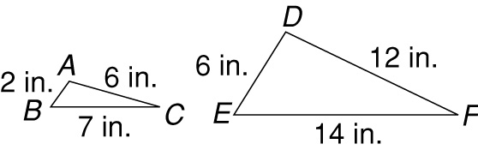

3. 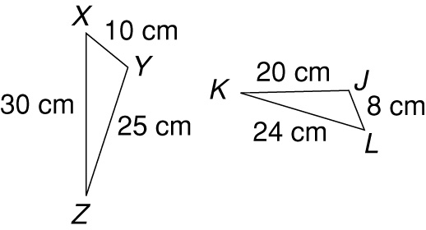

2. 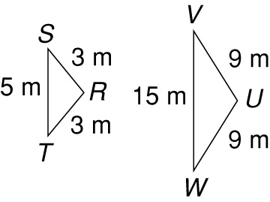

4. 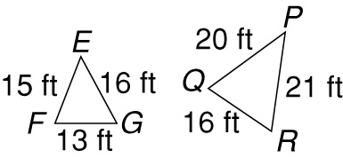

Tell whether the figures are similar.

5. 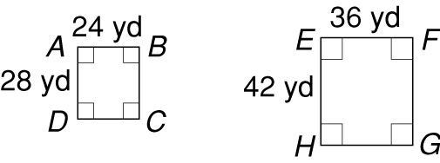

6. 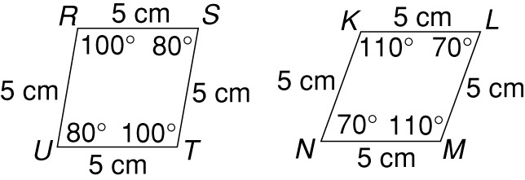

Answers for Lesson 4
Practice A
1. XY 2. YZ
3. XZ
4. similar; = = ;
= = =
5. not similar; ≠ ;
≠
6. similar; = = ;
= = =
7. Possible answer:
similar; = = ;
=
8. not similar;
≠ ; ≠
9. similar; = = = ; = = = =
Practice B
1. not similar; ≠ ;
≠
2. similar; = = ;
= =
3. similar; = = ;
= = =
4. not similar; ≠ ≠ ;
≠ ≠
5. similar; = ;
= =
6. not similar; corresponding angles are not equal
Practice C
1. similar; = = ;
= = = 2
2. not similar; ≠ ≠ ;
≠ ≠
3. not similar; = ≠ ≠ ; = ≠
4. not similar; angles are not equal
5. BC = 6 in.
6. = 29°, = 103°, = 48°
7. FJ = 4.9 cm
8. = 68°, = 74°,
= 90°, = 128°
Review for Mastery
1. 16; 2; 2. FG; ; ;
DF; ; ; FH; ; ;
DE; ; ; GH; ; ;
no; no yes; yes
3. similar
4. not similar; angles not equal measure

