Percents

Practice B: Estimating with Percents
Use a fraction to estimate the percent of each number.
1. 21% of 82 2. 35% of 42 3. 47% of 164 4. 9% of 68

5. 65% of 78 6. 11% of 92 7. 26% of 124 8. 89% of 51

9. 77% of 198 10. 5% of 75 11. 31% of 148 12. 53% of 539

13. In 2004, about $38 out of every $100 spent on advertising
was spent on television advertising. The amount spent on
radio advertising was about 21% as much as was spent
on television advertising. How much of every $100 spent
on advertising was spent on radio advertising? ____________________
Use 1% or 10% to estimate the percent of each number.
14. 32% of 46 15. 81% of 36 16. 15% of 44 17. 21% of 62

18. 3% of 72 19. 62% of 88 20. 12% of 48 21. 65% of 124

22. 18% of 147 23. 5% of 837 24. 37% of 213 25. 2% of 188

26. The Fresh Acres Swim Club has a $35,000 budget for
pool maintenance this year. The club members have
agreed to raise the budget by 4%. Estimate the pool
maintenance budget for next year. ____________________

Challenge
Possible path shown.
Problem Solving
1. 13.7% 2. 55%
3. mashed potatoes, 2%
4. 68.75% 5. D
6. J 7. D
8. J
Reading Strategies
1. 2. 70%
3. 0.45 4. 45%
5. Possible answer: Change the labels on the first bar so that the bar shows a total of 200, and each square represents 10 units. Then find the percent that is equivalent to 110 units.
Puzzles, Twisters & Teasers
1. 75%
2.
3. 81.25%
4. 0.84 84%
5. 0.55 55%
6. 0.075 7.5%
7. 17.5%
8. 45%
9. 0.045 4.5%
10. 0.825 82.5%
S U B M A R I N E S
Answers for Lesson 2
Practice A
1. C 2. G
3. A 4. H
5. B 6. J
7. D
Answers may vary. Possible answers given.
8. 20 9. 33
10. 60 11. 30
12. 20 13. 4
14. 6 15. 120
Answers may vary. Possible answers given.
16. 10 17. 2
18. 6 19. 35
20. 4 21. 30
22. 2 23. 27
Practice B
Answers will vary. Possible answers are given.
1. 16 2. 14
3. 82 4. 7
5. 50 6. 9
7. 30 8. 45
9. 150 10. 4
11. 45 12. 270
13. about $8
Answers may vary. Possible answers are given.
14. 15 15. 32
16. 6 17. 12
18. 2 19. 54
20. 5 21. 84
22. 30 23. 42
24. 84 25. 4
26. $36,400
Practice C
Answers may vary. Possible answers are given.
1. 13 2. 12
3. 55 4. 4
5. 24 6. 13
7. 330 8. 90
Answers may vary. Possible answers are given.
9. 24 10. 54
11. 16 12. 9
13. 5 14. 7
15. 81 16. 220
Answers will vary. Possible answers are given.
17. $2.30; $43.70 18. $1.00; $17.00
19. $1.20; $22.30 20. $2.00; $36.00
21. $5.00; $90.00 22. $0.70; $12.00
Review for Mastery
Possible answers:
1. 20%; 2. 60%;
50; 300;
; 50; 10 ; 300; 180
10 180
3. 5%; 4. 50%;
40; 530;
; 40; 2 ; 530; 265
2 265
5. 9 6. 150
7. 70 8. 48
Possible answers:
9. 10%; 5 10. 60%
280 60; 6; 10
10; 28 120
5; 14 10; 120; 12
28; 14; 42 6; 12; 72
42 72
11. 12 12. 72
13. 16 14. 120
Challenge
Estimates may vary.
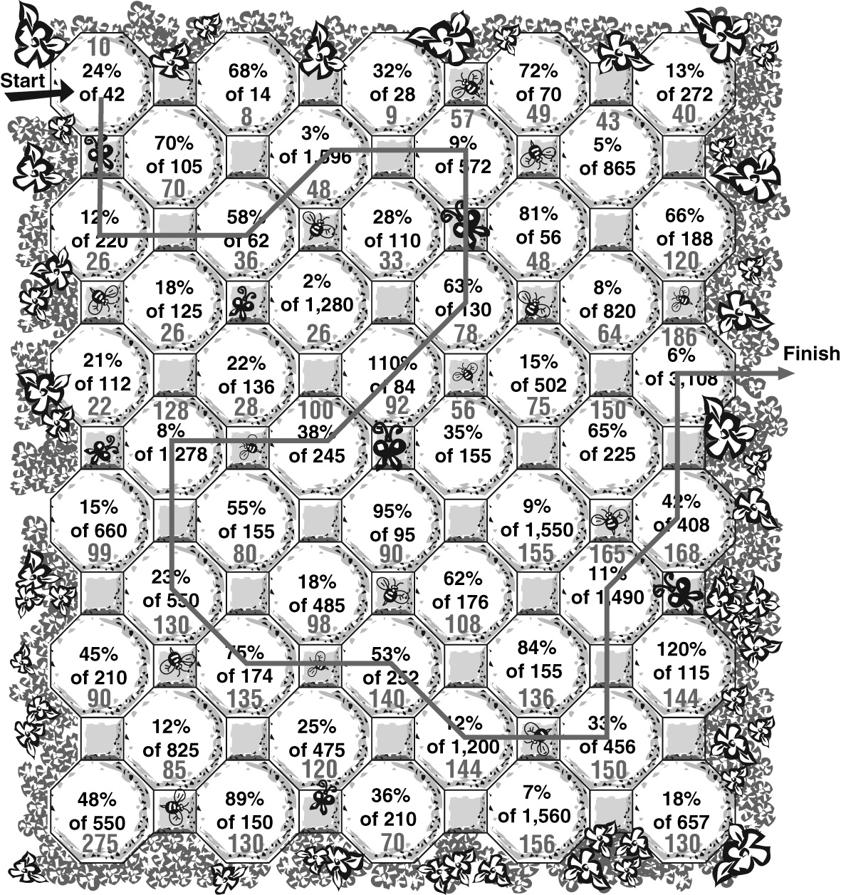
Problem Solving
Answers will vary. Possible answers are given.
1. about 25 visitors
2. Midwest region
3. about 140 visitors
4. about 850 shoppers

