Collecting, Displaying, and Analyzing Data

Practice B: Mean, Median, Mode, and Range
Find the mean, median, mode, and range of each data set.

1. 46, 35, 23, 37, 29, 53, 43

3. 19, 11, 80, 19, 27, 19, 10, 25, 15

2. 72, 56, 47, 69, 75, 48, 56, 57

4. 7, 8, 20, 6, 9, 11, 10, 8, 9, 8

5. The line plot shows the number of hours 15 students said they spent on homework in one week. Which measure of central tendency best describes the data? Justify your answer.
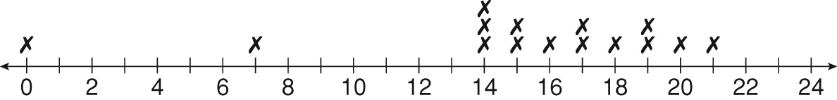

Identify the outlier in each data set. Then determine how the outlier affects the mean, median, and mode of the data. Then tell which measure of central tendency best describes the data with and without the outlier.
6. 14, 16, 13, 15, 5, 16, 12

7. 48, 46, 52, 92, 57, 58, 52, 61, 56

Collecting, Displaying, and Analyzing Data

Answers for Lesson 1
Practice A
1. 6; 5; 5; 6
2. 56; 56; no mode; 8
3. 20; 18; 18; 9
4. 35; 35; no mode; 50
5. 7; 5.5; 5 and 6
6. Possible answer: The median best describes the data set because it is closer than the mean to the number of kilometers that Clara ran the majority of the days. There are two modes.
7. 61
8. It increases the mean by 7 and the median by 1. It does not affect the mode, because there is no mode.
9. Possible answer: The median best describes the data set with the outlier.
10. Possible answer: The mean and median best describes the data set without the outlier.
Practice B
1. 38; 37; no mode; 30
2. 60; 56.5; 56; 28
3. 25; 19; 19; 70
4. 9.6; 8.5; 8; 14
5. The median best describes data set because it is closest to the numbers of hours reported by most of the students.
6. Outlier, 5; It decreased the mean by and the median by 0.5. It did not affect the mode. With the outlier, the data is best described by the median. Without the outlier, the data is best described by the mean.
7. Outlier, 92; It increased the mean by 4.25 and the median by 2. It did not affect the mode. With the outlier, the data is best described by the median.

Without the outlier, the data is best described by the mean.
Practice C
1. 17; 16.5; 17; 10
2. 53; 56; 56; 24
3. Possible answer: The median best describes data set because it is closest to the majority of the point totals.
4. Outlier, 10; It decreased the mean by 2.5 and the median 2. It did not affect the mode. With the outlier, the data is best described by the median. Without the outlier, the data is best described by the mean or the median.
5. Outlier, 103; It increased the mean by 4.75 and the median by 0.5. It did not affect the mode. With the outlier, the data is best described by the median or the mode. Without the outlier, the data is best described by the mean.
6. mode; Possible answer: No; the mode was higher than all of the other scores, and occurred only one more time than the score that occurred the next greatest number of times.
Review for Mastery
1. 5; 5.6; 6; 6
2. 8; 14; 15; 17
3. 16; 25.5; 24.5; 23
4. 10; 11; 11; no mode
5. 7; 42; 42; 42
6. 17; 61; 62; 62 & 68
7. 11 °F; 42 °F; 42 °F; no mode
8. It increases the mean by 3.8.
9. It increases the median by 1.
10. There is no effect.

