Collecting, Displaying, and Analyzing Data

Practice B: Box-and-Whisker Plots
1. Use the data to make a box-and-whisker plot.
19, 46, 37, 16, 24, 47, 23, 19, 31, 25, 42

Use the box-and-whisker plot of games won per season by
the New York Yankees and the Arizona Diamondbacks for
1998–2005 for Exercises 2–4.

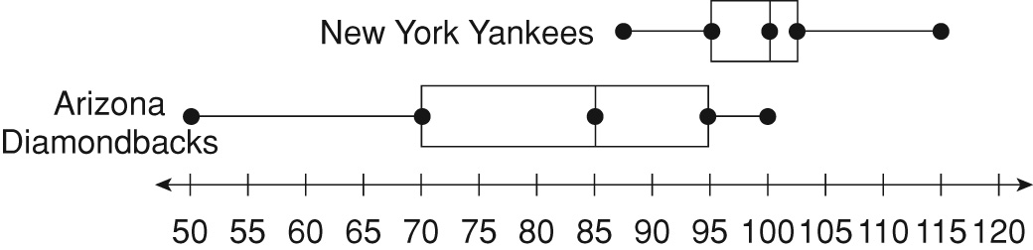

2. Which team has the greater median number of games won? _________________
3. Which team has the greater interquartile range of games won? _________________
4. Which team appears to have a more predictable performance? _________________
Use the box-and-whisker plot of nightly tip totals that a
waitress gets at two different restaurants for Exercises 5–7.

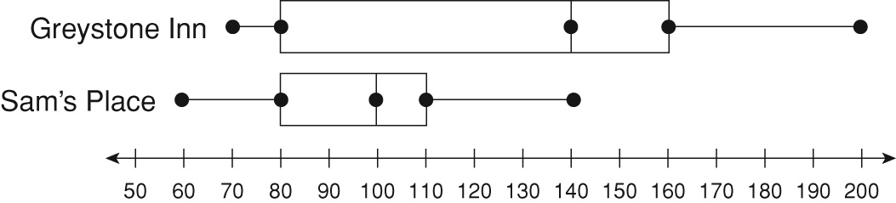

5. At which restaurant is the median tip total greater? _________________
6. At which restaurant is the interquartile range of tip totals greater?

7. At which restaurant does the tip total appear to be more predictable?

11. Yes; 25
12. It increases the mean by 3 and the median by 0.5.
13. The median best describes the data set because it is least affected by the outlier.
Challenge
1. Possible answer: 8, 10, 11, 11, 12, 14
2. 10, 12, 12, 16, 17, 18, 20
3. 8, 9, 9, 10, 14, 14, 15, 17
4. 14 5. 8
6. 33 7. 27
8. 91
9. He can’t do it. He would need to score about 108 on each quiz.
Problem Solving
1. 42
2. 69.4; 63; there is no mode
3. 100
4. It increases the mean by 7.65 and the median by 0.5.
5. Possible answer: The median; the outlier affects the median less than it does the mean.
6. A 7. G
8. C 9. G
Reading Strategies
1. mode 2. mean
3. range 4. median
Puzzles, Twisters & Teasers
T: 8
L: 4
I: 3.5
U: 11
R: 5.25
O: 5
E: 2
O U T L I E R
Answers for Lesson 2
Practice A
1. 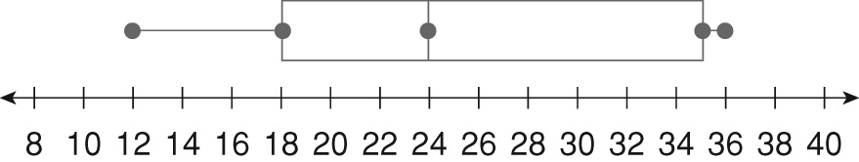
2. Amy 3. Ed
4. Ed
5. Amy; Possible answer: The range and interquartile range are smaller for Amy than for Ed, so Amy’s test scores are more predictable.
6. Port Eagle 7. Port Eagle
8. Surfside; Possible answer: The interquartile range is smaller for Surfside than for Port Eagle, so Surfside’s room prices are more predictable.
Practice B
1. 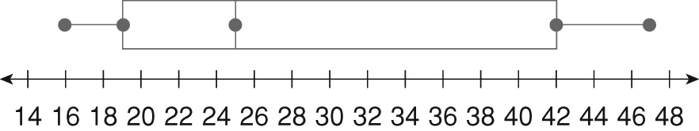
2. New York 3. Arizona
4. New York 5. Greystone Inn
6. Greystone Inn 7. Sam’s Place
Practice C
1. 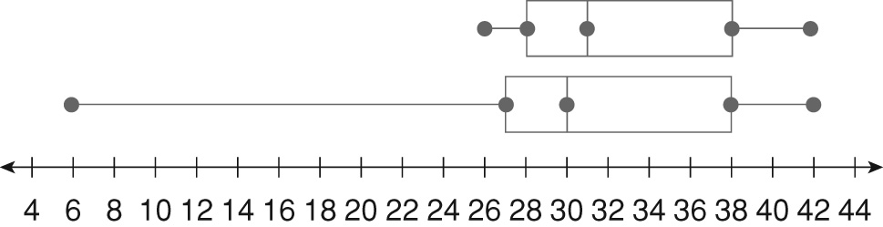
2. It increases the interquartile range by 1.
3. The range is more affected.
4. 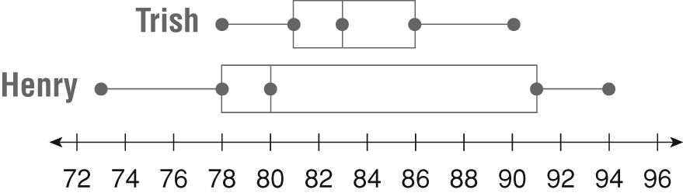
5. Henry 6. Trish
7. Trish

