Name: Date:
Period: Science Handbook

8th Grade Science
Student Handbook
2016-2017

Mr. Mocera
m.mocera@hackensackschools.org

Table of Contents

Purpose 3
Learning Objectives 3
Teacher Information 4
Rules 3
Academic Honesty 5
Detention 5
Grading 5
Lab Reports 8
Safety 9
The Extras 9

Welcome!

Welcome! We have an exciting year of science ahead of us. We will be investigating topics in physics and chemistry as well as incorporating mathematics and problem-based experiences into the learning process. It is my hope that you will all work towards and strive for excellence as we investigate these scientific ideas.

Purpose
This handbook contains the information you will need to prepare homework assignments, be ready for class, and participate in all activities throughout the year. Until you are familiar with all the rules and regulations, please use this handbook as a reference before coming to class, turning in homework assignments, taking tests, and preparing laboratory assignments, etc. This will help you be a successful learner.

Learning Objectives
Science is a process than involves observation and reasoning. We spend much of our time working in small groups observing and experimenting, both in the field and in the classroom. Scientists construct knowledge in the following ways. Students will be expected to mirror this process (Etkina & Van Heuvelen, 2001).
- conducting and describing observations
- devising qualitative and quantitative explanations
- actively participating in creating their own understanding of scientific phenomenon
- evaluating and analyzing evidence to draw conclusions
- designing and conducting experiments to test their explanations/models.
- draw conclusions and organize knowledge for use in more complex contexts

In this classroom, we use a learning and knowledge construction model called ISLE (Investigative Science Learning) cycle.
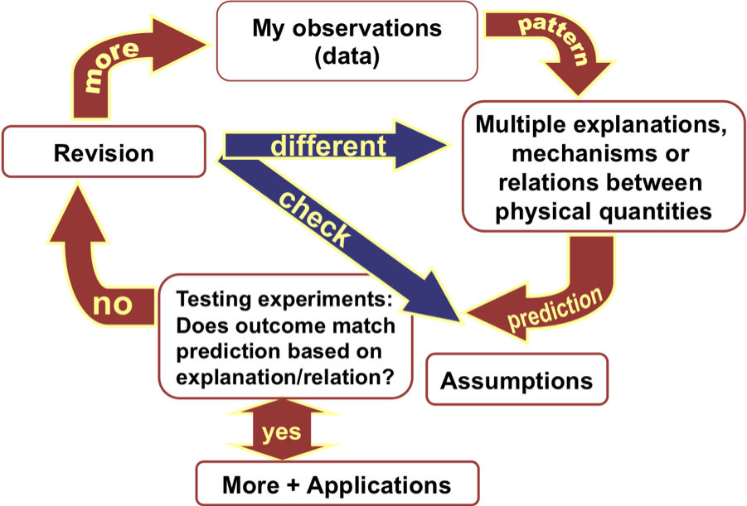
It is my hope that, whenever possible, students will challenge themselves to reach their own personal limits and to meet the learning goals presented to them. When in doubt, ask for help!!

Teacher Contact Information
Mr. Mocera: m.mocera@hackensackschools.org

web page can be accessed through School World:
www.hackensackschools.org/classroompages.cfm

Rules
School Rules: Familiarize yourself with the rules mentioned in the middle school handbook. All school rules will be enforced.

Class Rules:
- Enter the classroom, prepared for class and ready to learn whether early, late, or on time. Learning science is a process. We do not focus on right and wrong answers but rather how you can recognize patterns, extrapolate information, and draw conclusion. Quiz and test questions can not be answered as a result of rote memorization but rather true understanding. Therefore, it is critical that you are an active participant in all experiments and discussions as well as to record everything in your notebook.. Being prepared also means bringing necessary materials to class (see link below).

http://www.teacherlists.com/

- Contribute to a positive learning environment. Class participation is important but remember, there is an appropriate way to contribute. Be aware of other people’s feelings. This class is your job and you should present yourself in a professional manner. Talking out of turn or berating others’ thoughts and opinions is rude and unacceptable Racist and sexist comments are unacceptable.
- Respect yourself, respect others, and respect our school. We all have strengths and weaknesses. It is your job to get help when you need it. In addition, you have the right to learn in a safe supportive environment. In order for this to happen, we must all do our part.
- Take responsibility for your actions and accept consequences. When you do something well it is only fair to get the credit and praise you deserve. However, when you make a poor choice I expect you to face the consequences. It’s part of learning how to be an adult. Additionally, I expect you to email me when there is a class/school issue. Parent emails that pertain to you will not be responded to until you have communicated with me first
- Take pride in everything you put your name on and everything you do. This is your honor code. I do not respect those that do not put forth their best effort or take credit for another person’s work. The only person you are hurting is yourself.
- Meet your obligations as a classroom leader. You are expected to take responsibility as a leader. Once a week you will need to serve as a group leader and represent your group during activities.

Academic Honesty
Much of the time we will be working within groups; however, work still must be completed independently unless specifically noted. Plagiarism is when you submit the work of another under your name. This includes copying another person’s thoughts or ideas. Plagiarism and cheating of any kind is not tolerated. Any student caught doing either will receive a failing grade on the assignment as well as the person who let the copying occur.
Consequences
If rules are broken,
- 1st offense: Warning,
- 2nd offense: Student/Teacher conference
- 3rd offense: As described in Hackensack Student Handbook
- Subsequent Offenses: Report to guidance and/or Asst. Principle for disciplinary action

Detention
I do not expect to have to assign detentions but I will if you do not follow the rules and regulations. All detentions must be served at the time I specify. Most detentions will be served at lunch for 5-15mins. If you have other commitments at this time the detention will be on the following lunch period, do not do things that require detention. Failure to attend will result in a administrative detention. I wish to remind you that detention is not a study hall. You will not be permitted to do school work or talk during detention time.

Grading
I expect that you will track your progress online with your parents or guardians. All graded work will be returned as quickly as possible. Your grade will be based on what you know/understand as well as how you perform in a variety of tasks throughout the marking period. All tasks are worth points. For example, a class assignment might be worth 10 points. If you complete it satisfactorily, and turn it in on time you will earn 10 points. A test may be worth 100 points. If you earn 90 points on the test, it will become part of the total number of points you earned for the marking period. Your grade will be the percent of points you earned throughout the marking period compared to the total possible points in the marking period. I do not believe in grade inflation, but I will adjust scores if I feel the assessment is unfair.
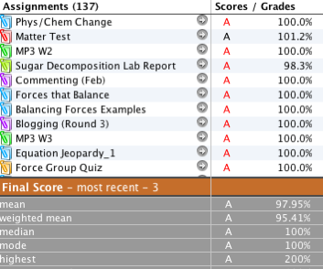
- Projects: I will probably assign one project per marking period. You will usually be given the option of working on the project individually or with another student(s). Since this project will usually involve research, you will be given at least 2 weeks to complete it from the time it’s assigned.
- Tests and Summative Assessments: Most tests cover an entire unit’s worth of information. Therefore, I will try to give at least 5 days notice. I will try to hold a review session the afternoon or morning before the assessment. These sessions are designed to answer specific questions you may have while studying. You are always welcome to attend whether or not you have questions to listen to those constructed by classmates.
- Quizzes and Formative Assessments: Quizzes cover small amounts of information (a chapter, homework assignment, reading, or recently developed concepts) and may take many forms (concept mapping, essay, diagramming, etc). I will not give you as much notice as with tests and, on occasion, will not give you any notice.
- Scoring
Tests/Project 40%
Quizzes 30%
Class work/Lab 20%
Homework 10%
- Expectations for Assignments: All assignments are very important for student learning and for teacher assessment of learning. Therefore missing work is not acceptable for any reason. The student will communicate with their teacher a timeline/path to make up assignments when not completed for any reason. Late work may be deducted points as a penalty by the teacher, depending on the reason/timing of the missing work.
- Lab Report: These reports contain detailed information about a laboratory exercise you have completed. It is a very important part of learning how tested observations and ideas are examined, analyzed, and then utilized by other scientists. (See lab report section for details)
- Homework: Homework serves several purposes: to review information discussed in class, to get students to research new topics that will be introduced, or to assess the prior knowledge students have on a topic. If you don’t know an answer, it is okay. But you still must try to answer it. Remember, science is about the process of discovery, not about right or wrong answers! Homework is assigned most nights and can be accessed from the class website. All homework will be checked for completeness and effort.
- Homework must be turned in completed and on the assigned date. Incomplete and/or late assignments will be granted credit but points will be deducted if late. In this class assignments must be completed and handed in, missing assignments will be completed by the student to enable the teacher/student a chance to measure/show learning. Please see me prior to any special circumstance that may prevent you from turning in your homework.
- Homework assignments must be written out and answered in complete sentences (as you learned in Language Arts) unless otherwise noted. Answers must include a full explanation, examples, and work to receive full credit. No credit will be given for answers unaccompanied by work that shows the process by which you derived them. The student will redo that work for credit. Colloquialisms, slang, and online/text abbreviations are not acceptable.
- Absence from school is the only reason for not turning in your homework on time. If you miss class for any reason other than absence, you are responsible to obtain the assignment and turn it in on time. You will have 3 days to make work up for full credit when absent. It is assumed that you can handle all of your responsibilities, this includes communicating with your teacher a timeline to make up all missing/late work.
- I expect that you will write all homework assignments in your agenda or check the website regularly for your work. Homework will be posted on the class website every afternoon by 3:30pm. Please confirm the assignment (or lack of an assignment) with a classmate.
- Assignments can always be emailed but you should always bring a backup copy on a flash drive in the event of computer/network error.
- Class Participation: All students are expected to come into the classroom ready to learn. This does not just mean answering questions correctly. This means walking in quietly, beginning any activities written on the board, writing down your homework, and being prepared with all materials. Many times, asking questions is more important than answering them. I encourage you to ask questions about things you do not understand. Participation in cooperative learning groups is also important. If you do not help your group, this means others must do your work for you and that is not fair. The student’s grade will be affected if these attributes are not regularly exhibited.

Lab Reports
Lab reports consist of following sections and information:
- Background – this includes the reason(s) you are doing the experiment and what background information the audience needs to know in order to understand your experiments and results. Think of this as a recap like on a television show… what you need to know to understand the episode.
- Hypothesis - A hypothesis is a possible general explanation for an observed phenomenon that may be tested through experimentation.
- Prediction –A prediction is a statement specific for the experiment that utilizes the idea generated by the hypothesis. Ex: If (hypothesis or model is true) and (we do this testing experiment) then (we should see this prediction based on the hypothesis/model).
- Materials – A list of all the materials, chemicals, and equipment needed to do the experiment. Be sure to give specific quantities where necessary.
- Procedure – The procedure tells exactly what you did when experimenting. It is important that the details are accurate so that someone else can follow the procedure. The procedure should be written before the experiment is undertaken and then amended during the experiment to account for any alterations.
- Observations/Data – The observations tell exactly what happened when you did the lab. An observation is a measurable piece of information that comes to you through your senses. It may also include qualitative descriptions. This section also includes experimental data in the form of well-labeled tables, graphs, drawings, and other observations. Key pieces of data may be highlighted here for further discussion in other sections.
- Calculations – Any and all calculations should be included here. This should also include your percent error.
- Conclusions – conclusions explain what your observation could mean and describe how your data relates to the prediction. Inferences are made based on the data. You should comment on the implications this has for your hypothesis. In other words, does the data support your hypothesis? Your conclusion may contain a new hypothesis based on your findings. It must also introduce any assumptions/confounding variables that may have been made that could have skewed your results.
These reports must be typed up on the computer, either at home, or in school. See me if you ever have need for a computer.

Safety
Following safety procedures is critical in a lab setting. This is a list of general rules to keep you and the rest of the class safe.
- Conduct yourself in a responsible manner at all times in the laboratory.
- Follow all written and verbal instructions carefully. If you do not understand a direction or part of a procedure, ask the instructor before proceeding.
- Never do any experiments without the approval and direct supervision of your teacher.
- When first entering a science room, do not touch any equipment, chemicals, or other material in the laboratory area until you are instructed to do so.
- Never fool around in the laboratory. Horseplay, practical jokes, and pranks are dangerous and prohibited.
- Be alert and proceed with caution at all times in the laboratory. Notify the instructor immediately of any unsafe conditions you observe.
- Know the location of all safety equipment in or near your classroom. Never play with the safety equipment.
- Keep the aisles clear. Push your chair under the desk when not in use.
- Clean up your work area upon completion of your activity.
- Wash your hands with soap and water upon completion of an activity.

The Extras
- Extra Help: I offer extra help to any student that makes the request. Students should consider what they are struggling with prior to coming so we have goals for our session. My extra help sessions are below but please let me know you’re coming. Walk-ins are welcome!

Homeroom and Study Hall time: Everyday
Before / After School: M W TH (Until 3:30)
By appointment: At an arranged time

