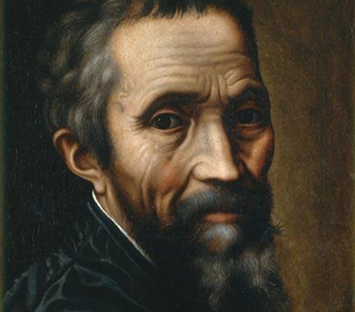 Iliana Abreu

ESL II

March 15, 2013

**Michelangelo**

The person I will be researching for this paper is Michelangelo, an artist. I chose this person because I love learning about sculptors and art. Michelangelo was an important figure in history because he was an artist.

He was born on 1475 BC and died in 1565 BC. He was born in Caprese, Italian. Michelangelo was sent to a private school. Michelangelo was a painter, sculptor, architect and poet. Michelangelo was one of the most famous artists of the Italian renaissance. Michelangelo was placed with a family of stonecutters where he lasted jested. He moved into the place of powerful Medici family to study classical sculpture in the Medici gardens. Michelangelo father realized early on that his son had no interest in the family financial business so agreed apprentice him at the age of 13 to the fashionable Florentine painter’s workshop.

Michelangelo’s achievements are the pieta a marble sculpture of Jesus dead on the lap of Mary his mother. After the crucifixion, also of David from the famous bible story. Michelangelo also created two of the most influential works in fresco in the history of western art. The scenes of genesis in the ceiling and the last judgment on the altar wall of the Sistine chapel of Rome. Michelangelo was a very hard worker.

Work cited

www. Biography.com/people/Michelangelo

www.voices.yahoo.com