**Scientific Method: Conclusion**

August 22, 2010 By [Janice VanCleave](http://scienceprojectideasforkids.com/author/Janice-2/)

A **conclusion** is a summary of the experiment.

For a cause-effect experiment, the conclusion should state the hypothesis and and tell whether the results of the experiment supported the hypothesis. If the results did not support your hypothesis, say so, and then add information about why this happened**. (include sections (A) and (B) in** **your conclusion also) see below:**

**For Example:**

If the cause-effect experiment has the following problem, hypothesis,data, and results, the conclusion might be stated as shown below:

**Problem:**

How does amount of yellow coloring added to blue water affect the shade of green produced?

**Hypothesis:**

If the amount of yellow coloring is increased, then the green shade of the water increases.

**Data:** The chart is an example—-Is it correct?

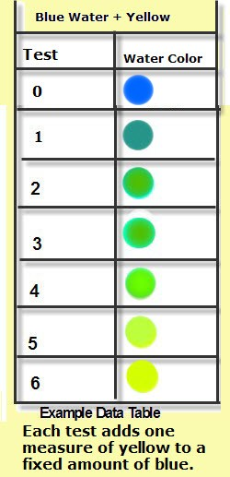

(**Challenge:** Perform the experiment and let me know your results.)

Right or wrong, the data chart is used to write the results

**Results:**

As the amount of yellow is added to the blue water, the color changes to blue-green, which changes to green, and then to a yellow-green.

**Conclusion:**

My hypothesis for this investigation was, “If the amount of yellow coloring is increased, then the green shade of the water increases.” The results of the experiment did not totally support my hypothesis. The first three measurements of yellow supported my hypothesis that adding yellow to the blue solution would increase the production of a green solution. But, as more yellow was added, the solution’s color became more yellow.

1. **Further Investigations– explain this in your conclusion also**

Often the results of an experiment will bring up questions that lead to further investigations. Explain in your conclusion what you learned and how your new knowledge can be applied to other situations or a new idea/hypothesis you could test in the future.

1. **BELOW explains questions you should answer if your Hypothesis was incorrect**

http://www.brandonbeltz.com/scimeth/images/title.gif

**Conclusion |** Overview

The fifth step of the scientific method is to draw a conclusion. Scientists draw conclusions by examining the data from the experiment. There are basically two possible outcomes. Either the experiment supported the hypothesis and can be regarded as true, or the experiment disproved the hypothesis as false. If the hypothesis is false, repeat the steps in the scientific method and make adjustments to your hypothesis.

**If the hypothesis turns out to be false, there are some questions to ask to find out why and explain/answer in your conclusion:**

1. **What was wrong with the original hypothesis? Were all** the variables tested measurable, was your prediction way off?....give examples that led you to think this way.
2. **Did you make poor observations?** Give examples or reasons
3. **Was your experiment flawed?** Explain how your procedure or technique of the experiment was not done correctly….give examples of what you thought went wrong.