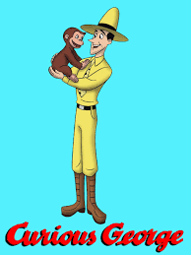

There was a monkey named George. He was curious. There was a man. His name is the man with the yellow hat. I know you will love it.